Project Notes

Click here to enter text.

Specimen Notes

Click here to enter text.

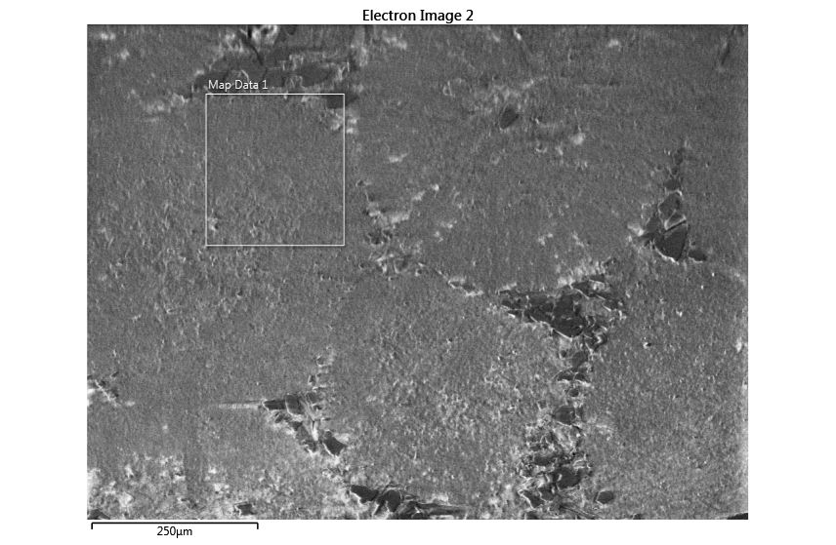

Settings

|  |  |
| --- | --- |
| Accelerating Voltage | 20.00 kV |
| Specimen Tilt (degrees) | 70.00 ° |
| Hit Rate | 58.75 % |
| Speed of Acquisition | 40.51 Hz |

Phases for Acquisition

|  |  |  |  |  |  |  |  |  |
| --- | --- | --- | --- | --- | --- | --- | --- | --- |
| Phase | a | b | c | Alpha | Beta | Gamma | Space Group | Database |
| Calcite | 4.99 Å | 4.99 Å | 17.06 Å | 90.00 ° | 90.00 ° | 120.00 ° | 0 | HKL |
| Quartz-new | 4.91 Å | 4.91 Å | 5.50 Å | 90.00 ° | 90.00 ° | 120.00 ° | 152 | HKL |

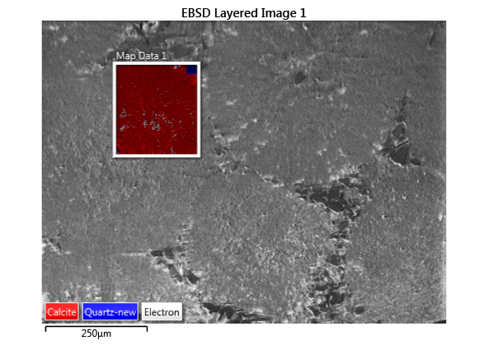

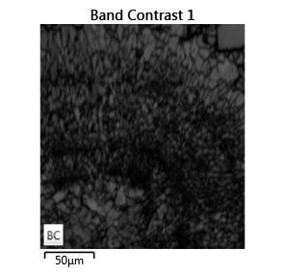 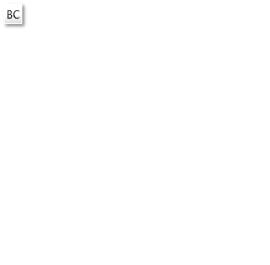

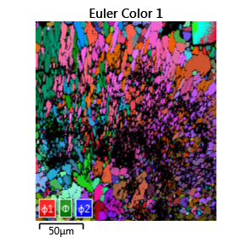 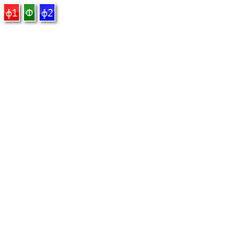

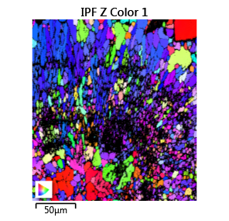 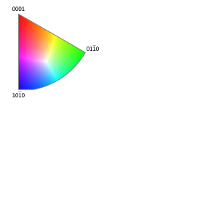

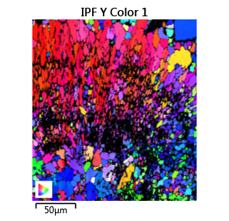 

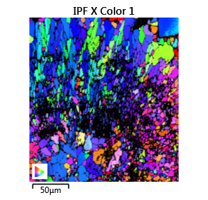 

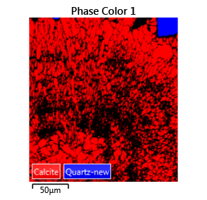 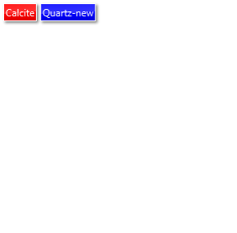

Phase Fraction

|  |  |  |
| --- | --- | --- |
| Phase Name | Phase Fraction (%) | Phase Count |
| Calcite | 57.14 | 169941 |
| Quartz-new | 1.62 | 4811 |
| Zero Solutions | 41.25 | 122678 |